AUTOMATIC NIGHT LAMP

Circuit diagram:

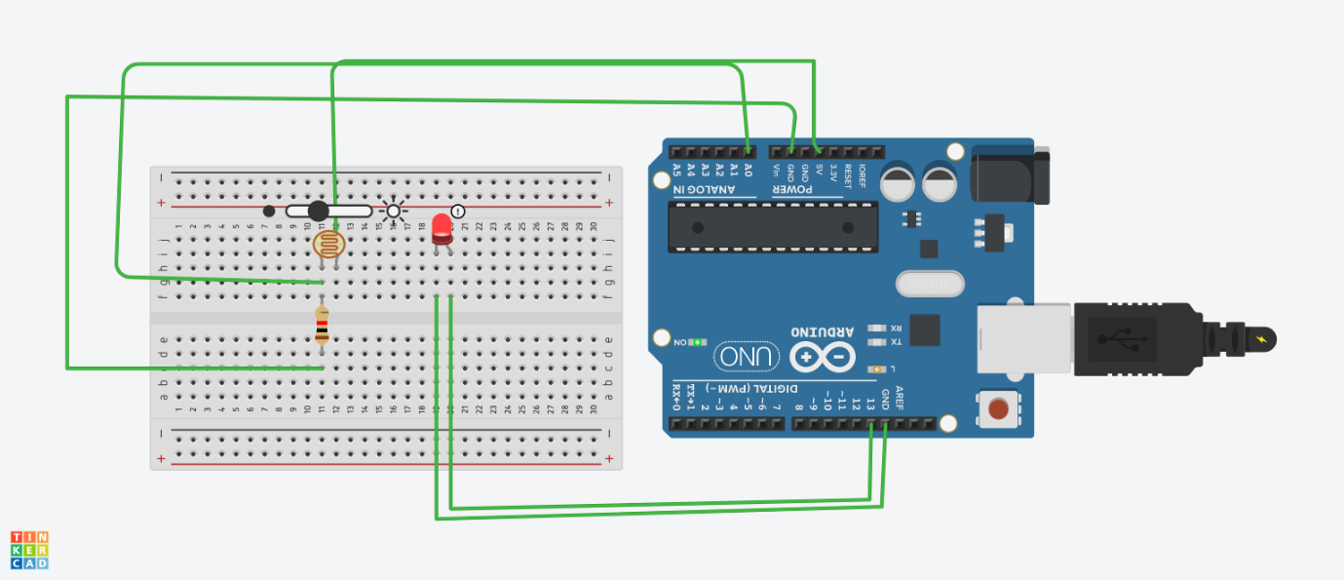

Theory:

CONCEPT USED:

➢ By using kirchoff’s voltage law &

➢ By using kirchoff’s current law

➢ Series and parallel connections

LEARNING AND OBSERVATIONS:

• Connections in Breadboard and wiring.

• How to control arduino and its coding.

• Use of multimeter for continuity.

OBSERVATION:

➢ Blinking of led as the sensor reads the specified value i.e automatic glowing of led with the intensity of light .

➢ Relation between software and hardware

PROBLEMS & TROUBLESHOOTING:

o To select the right port and type of arduino

o To check the loose connections

o To check the connections according to the codes

o To check the continuity of the circuit

o To check the flow of current in the circuit

PRECAUTIONS:

o Handle tools carefully

o Wear gloves

o Do not connect arduino till the circuit is complete

OUTCOMES:

o It is used in street lights.

o It can be used in alarm locks and burglar alarm circuits.